Connecting to linux via citrux

First to to the following URL [vsov.dit.ie /](http://www.comp.dit.ie/techsupport/vsoc/) or <http://vsoc.dit.ie/Citrix/vSOCWeb/>

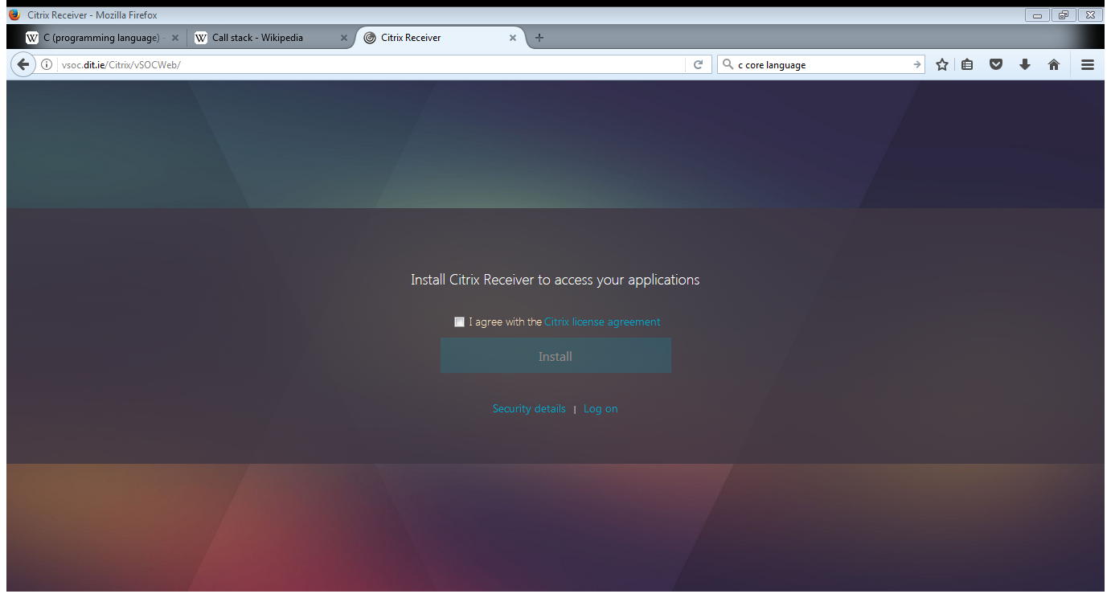

Click agree and install: this should open a window to download

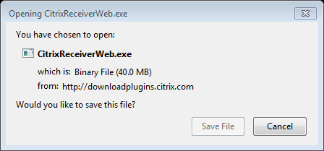

Save and install the file

Go back to the browser which should direct you to the log on page: <http://vsoc.dit.ie/Citrix/vSOCWeb/>

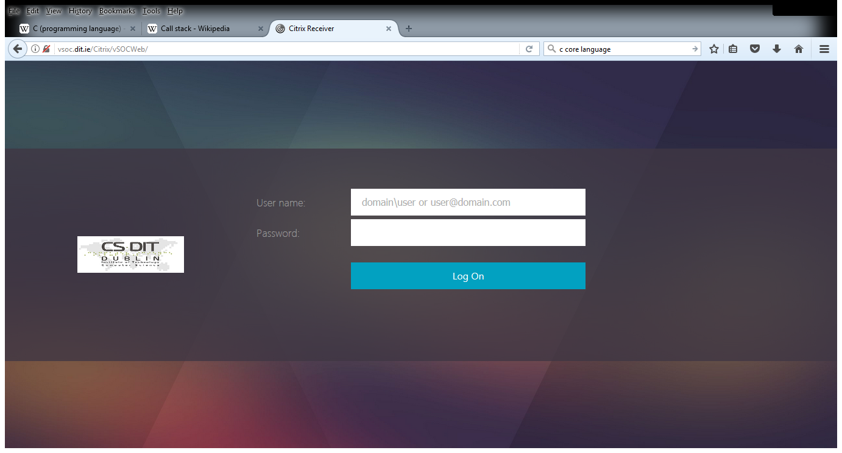

Log on using (as indicate) ictdomain\username and passwork

This should then bring you to the following page

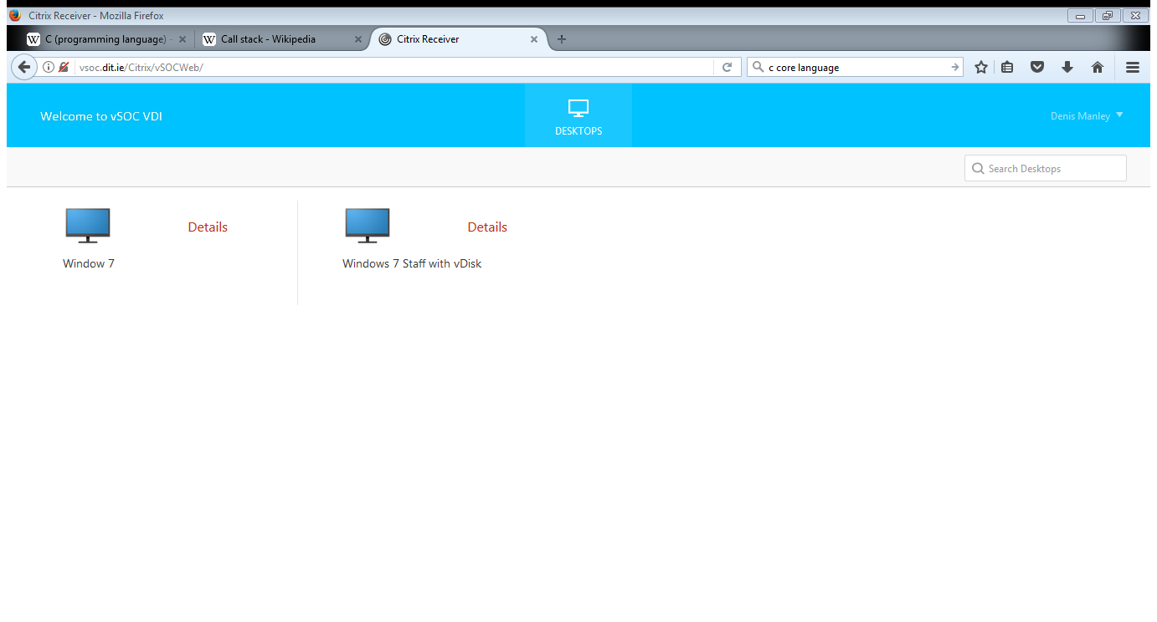

Click on the window 7 option and it should give you the following dialog box.

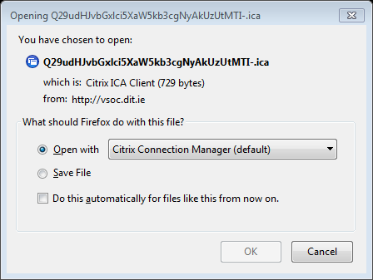

Open and it should display the following screen saying connecting to desktop (as if you were in the labs)

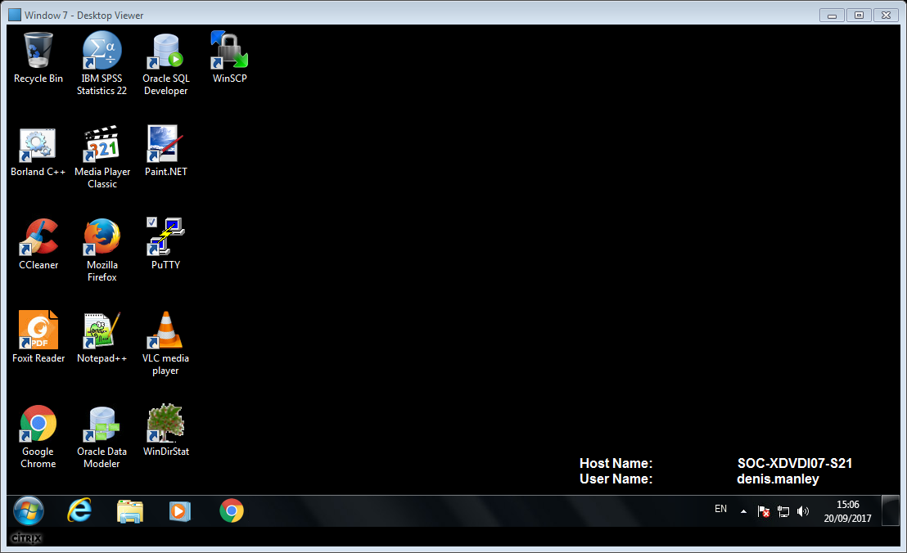

Click on putty and continue as explained in lab 1.